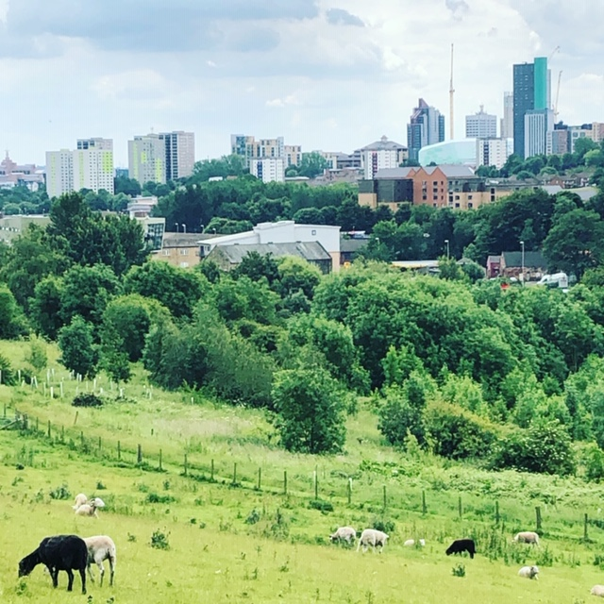

Sugar Well Road, Leeds LS7 2QG
Tel: 0113 262 9759
Email: admin@mvuf.org.uk www.mvuf.org.uk
Registered in England. Charity Registration No. 510452 Company No. 1509788

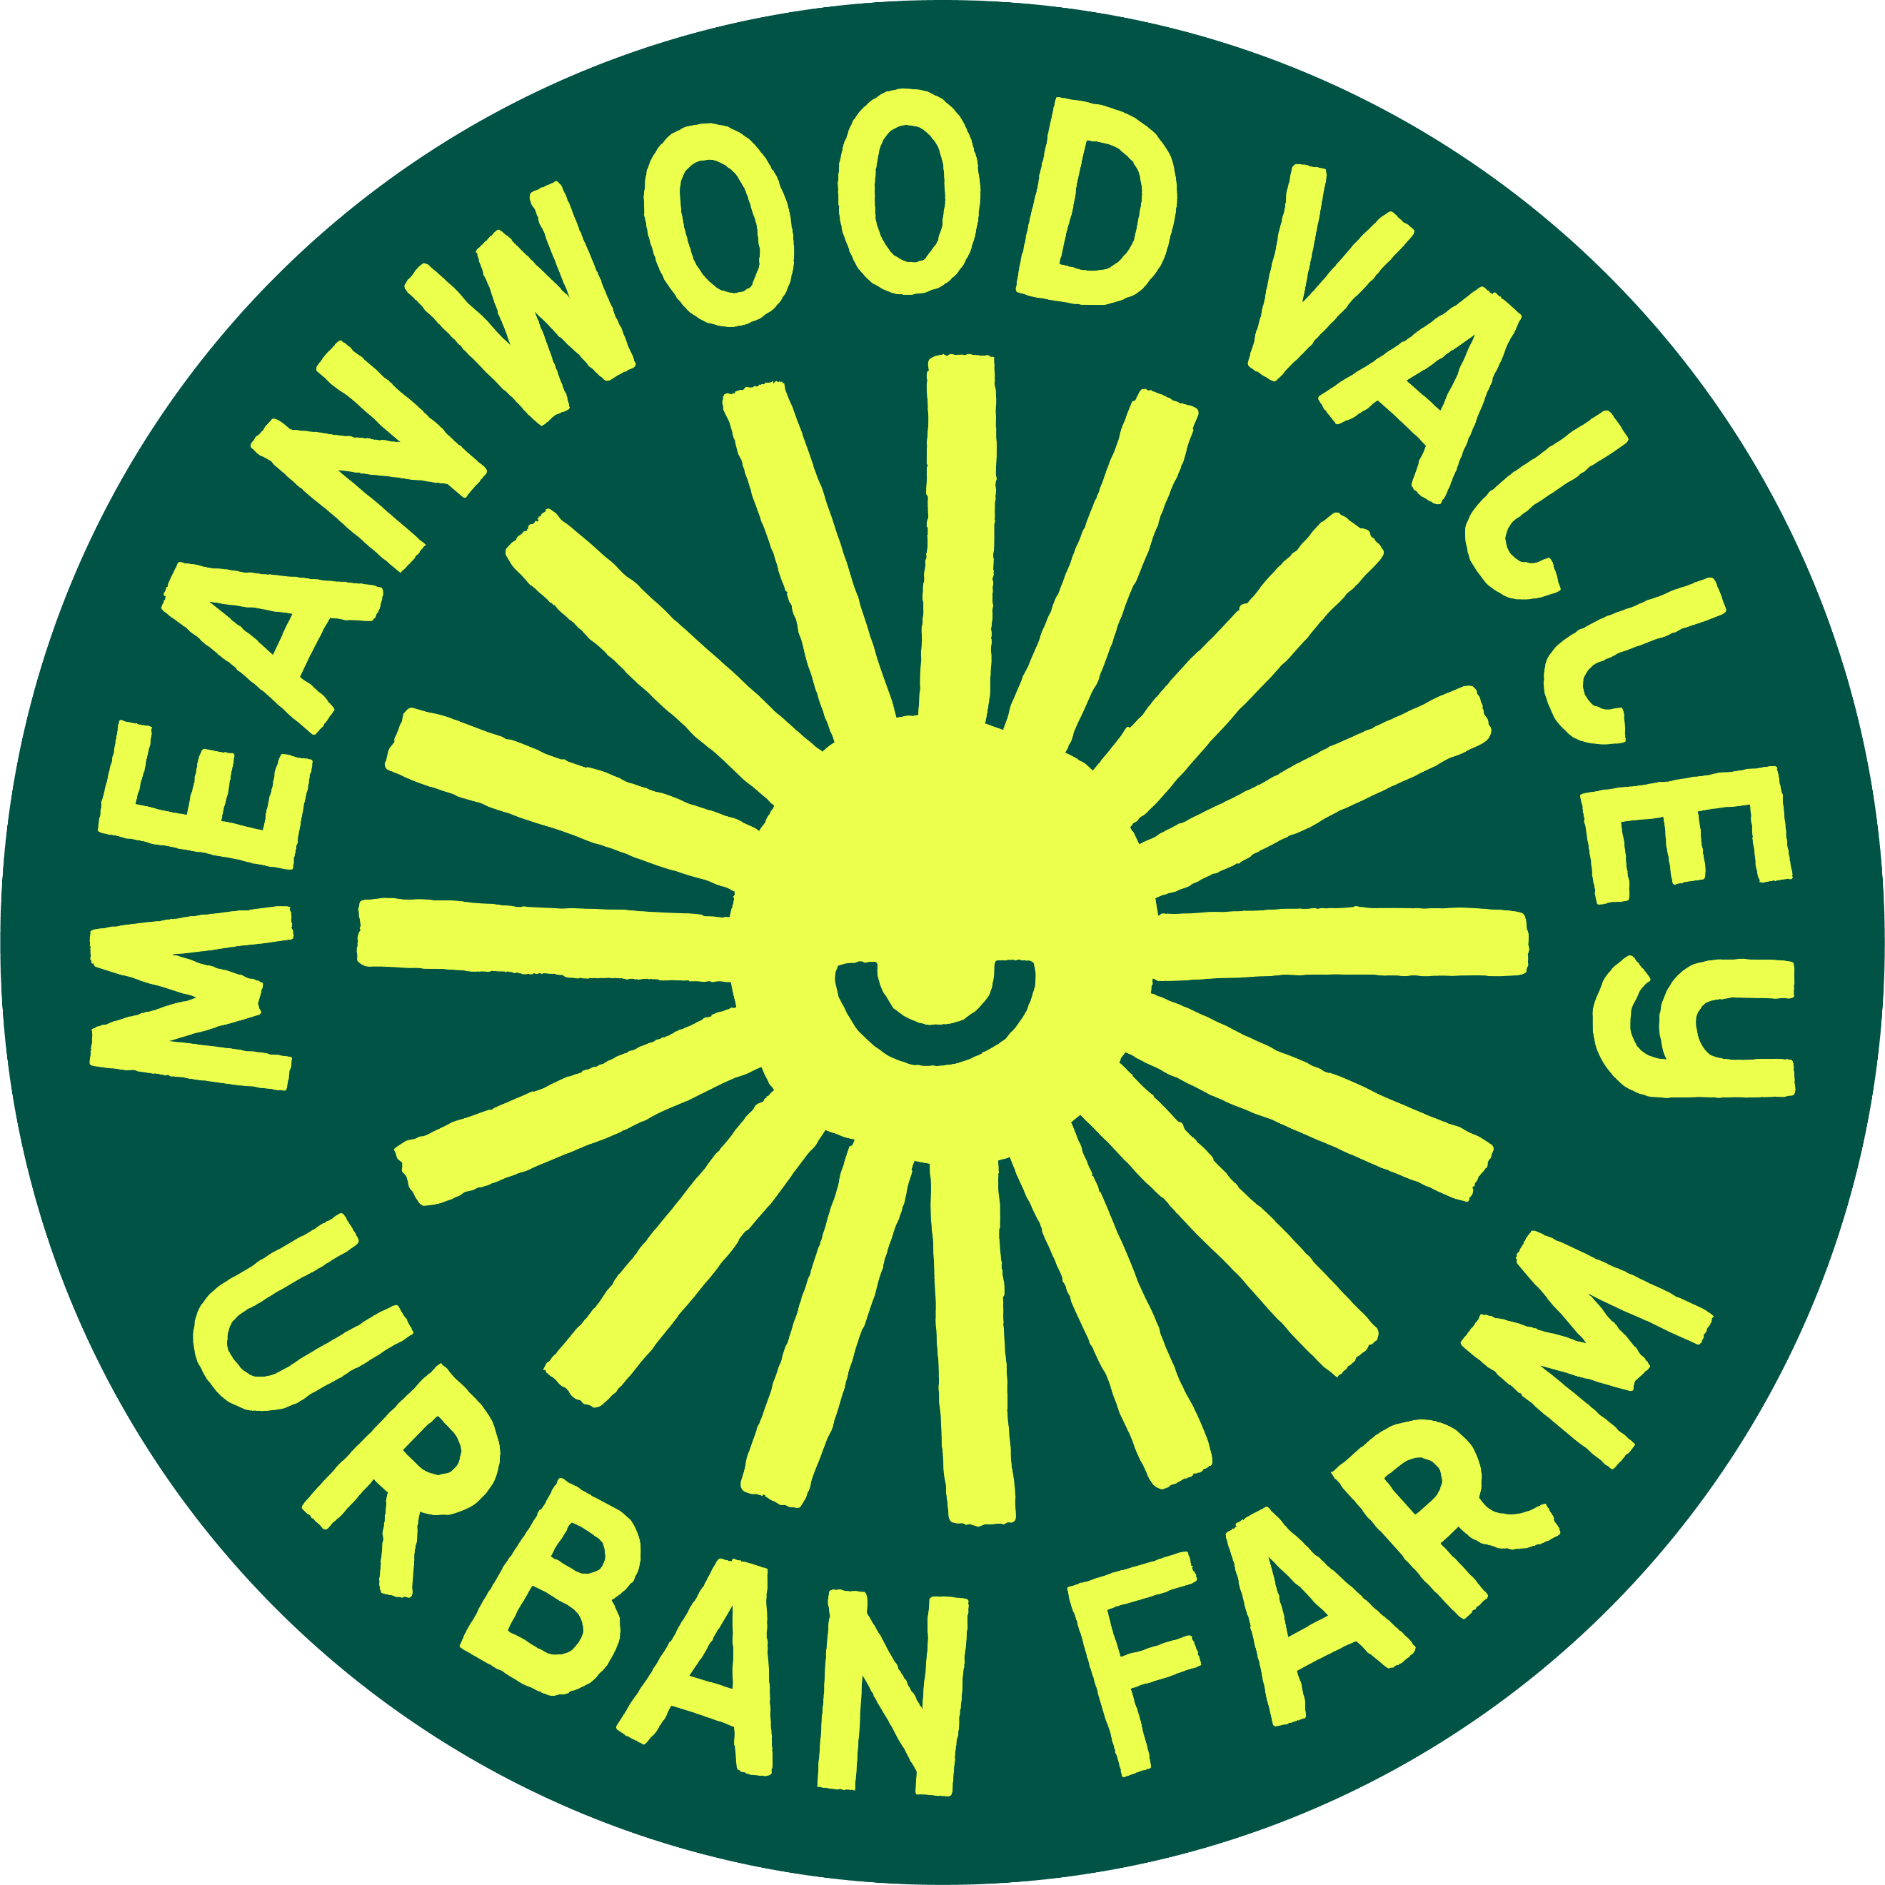
Meanwood Valley Urban Farm
Communications & Engagement Officer Job Pack

1.Background

Meanwood Valley Urban Farm (The Farm) was one of the first three city farms in the UK and was registered as a charity in 1980. It began with two small fields and a few animals and has developed into a site of about 26 acres with 20 paid members of staff.
It comprises meadows, pastures, market and ornamental gardens, woodland and a variety of wildlife habitats.
The charity objectives are as follows:
1. To provide recreational facilities and green space for recreation and other leisure-time occupation in the interests of social welfare with the object of improving the conditions of life, providing connection and wellbeing for those living or working in Meanwood, Leeds and surrounding areas [hereafter known as the “area of benefit”], for the public benefit.
2. To promote the importance of restoring, maintaining and increasing biodiversity, our ecological impact, environmental awareness, and sustainable agriculture and horticulture, through the education of visitors and wider audiences through online platforms, for the public benefit.
3. For the public benefit, promote, sustain and increase individual and collective knowledge and understanding of sustainable agricultural and conservation principles including animal welfare, food production, and impacts on nature and ecology through both formal and informal education for all ages and abilities within the area of benefit.
4. To provide opportunities for education including personal and vocational skills development amongst those in need from the area of benefit, including young people and adults from disadvantaged backgrounds or with physical, cognitive or sensory impairments, for the public benefit.
5. To promote improvement to mental and physical health through a community programme of recreational and therapeutic activities and focussing on services for people from the area of benefit including those with physical, cognitive or sensory impairments; and those living with mental health issues, for the public benefit.

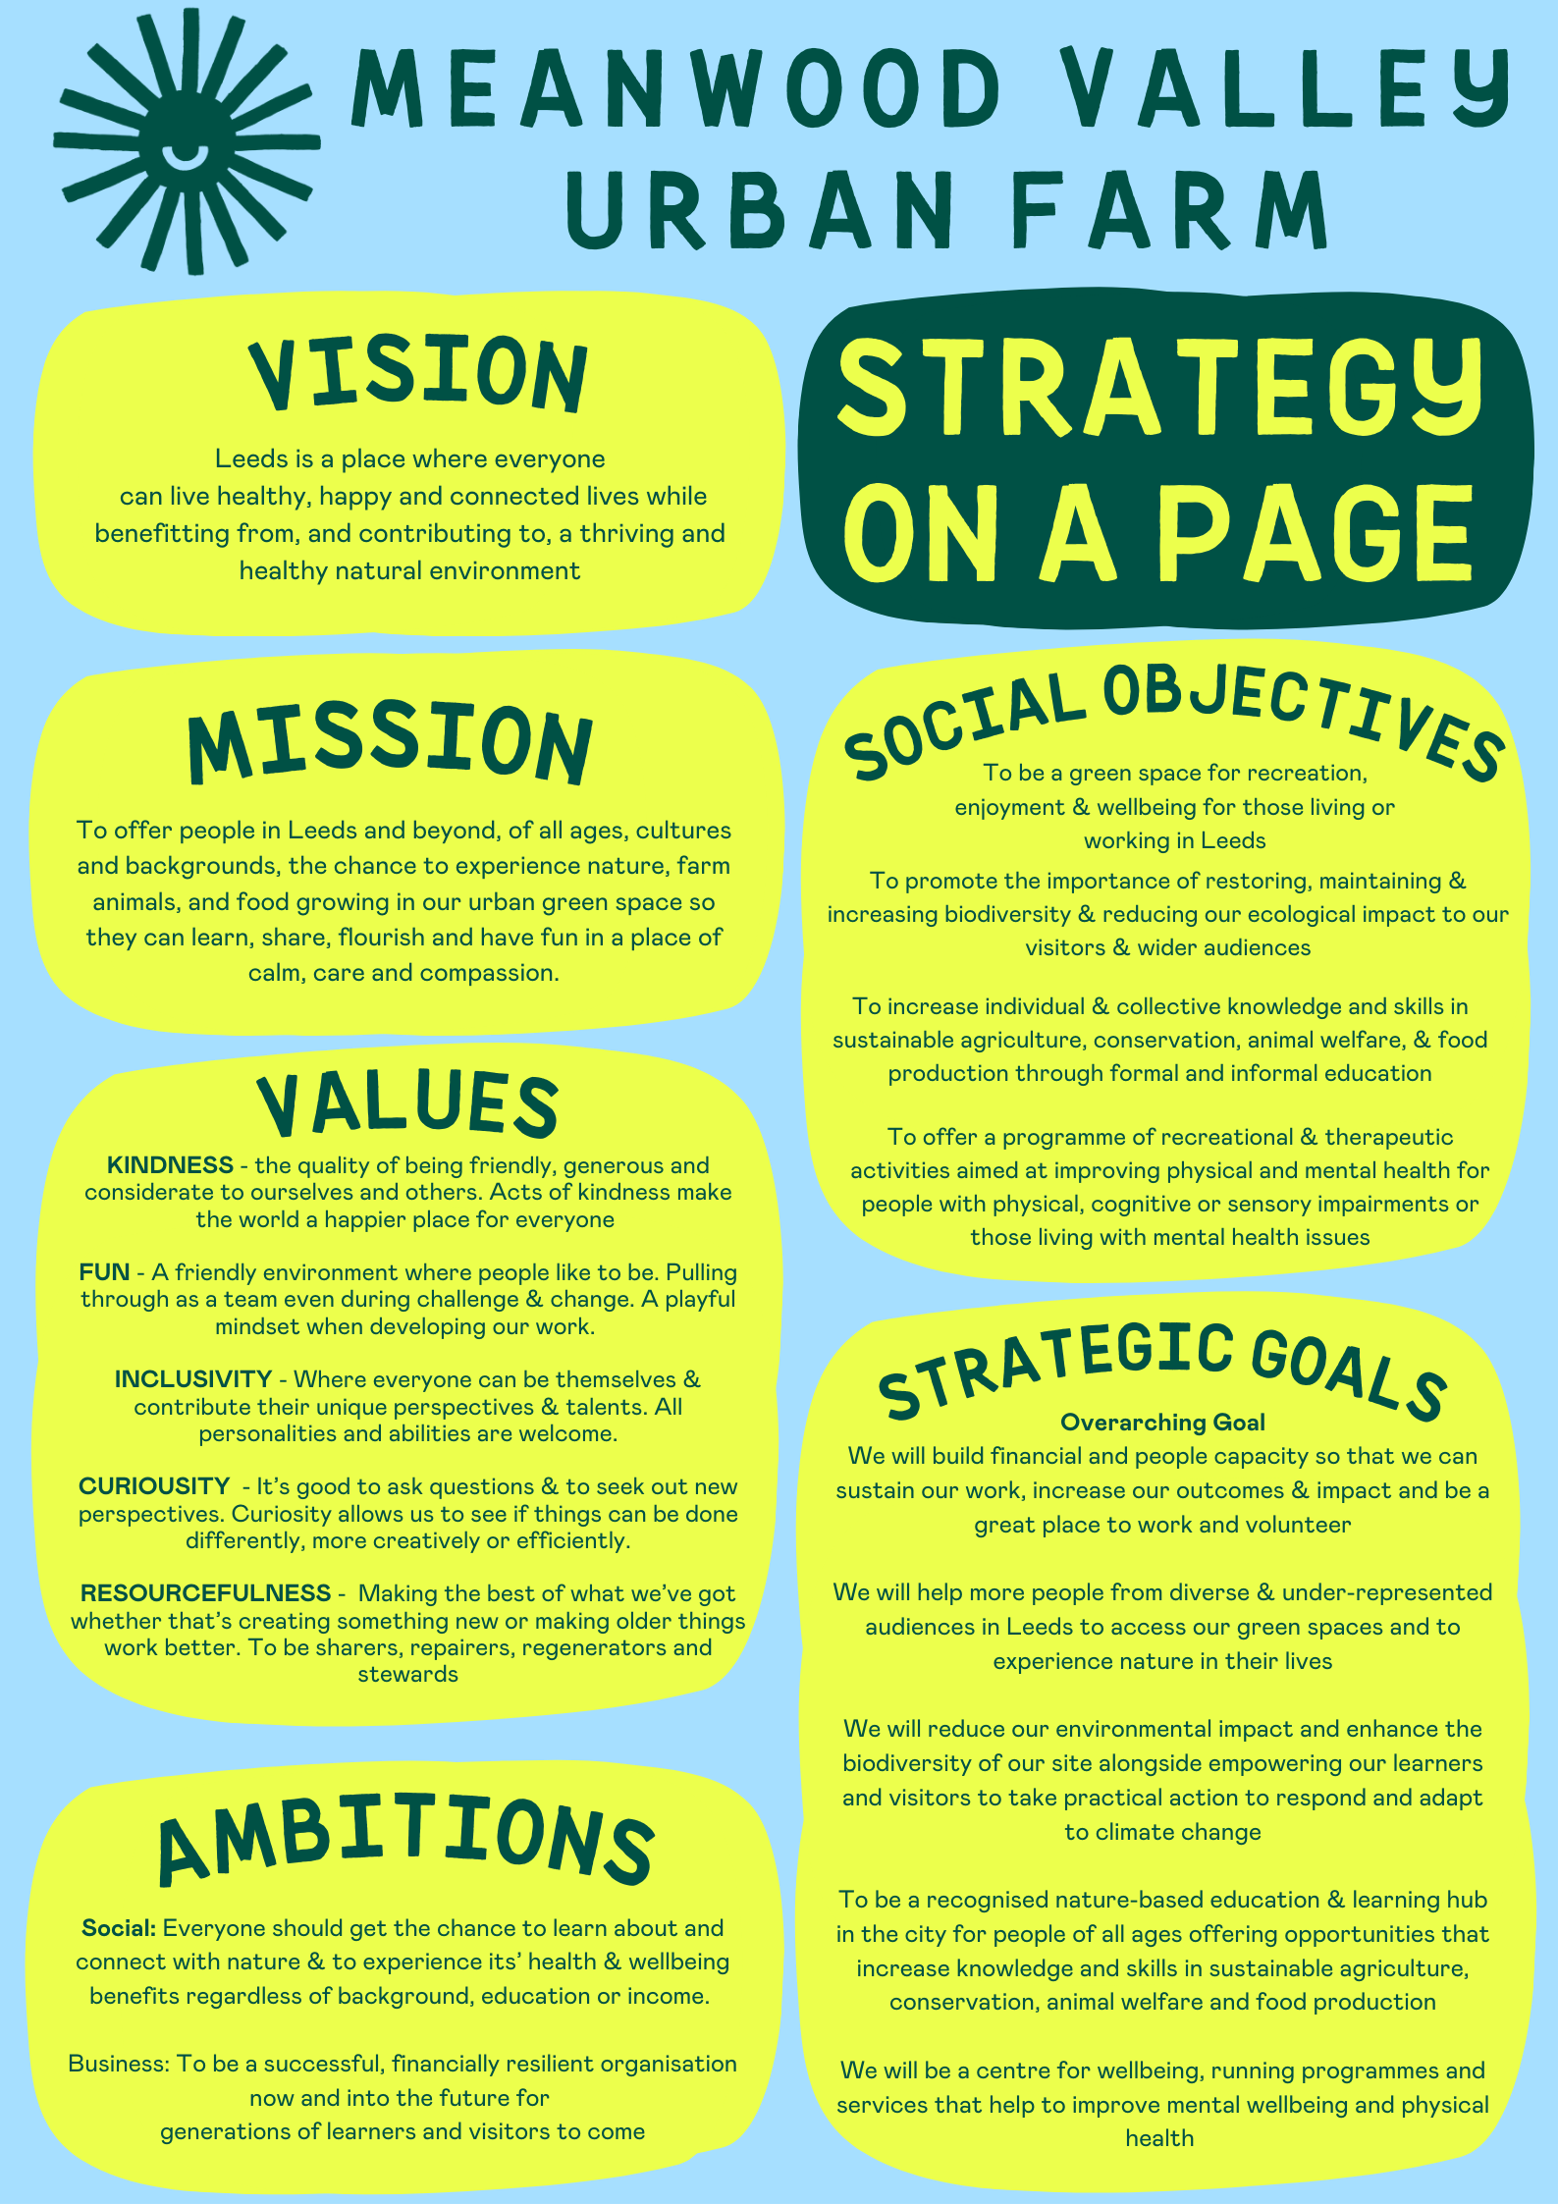

2. Services
HOOF (Helping Out on The Farm) – a programme offered to adults with learning disabilities who work alongside the Horticulture Team and the Animal Care team as well as undertaking lots of different activities around the farm
Schools – outdoor environmental education visits lead by a member of the Education Team undertaking curriculum-related activities.
Market Garden – chemical free fruit and veg grown on our 1 acre market garden run as a Community Supported Agriculture Scheme including a successful veg box scheme for local people, and selling our products in local café’s restaurants and wholesalers and surplus food donated to Rainbow Junk-tion – a local independent Pay-As-You-Feel community café which aims to reduce food waste, feed hungry people and build community
Community – a number of events are organised throughout the year including activity trails, Summer Fair, Apple Day and Christmas Market. In addition, a number of third-party events are hosted including workshops and outdoor activities.
Forest School activities for parents and toddlers provided by qualified instructors.
Volunteering – we offer opportunities for adults to volunteer on our market garden, as well as opportunities to help us to maintain the 26-acre site and occasionally to work alongside staff providing some of our services. We also offer volunteering days for corporate groups.
Visitor Attraction – we are open to the public 7 days a week 10am-4pm, 362 days a year with around 22,000 members of the public visiting each year.
You can find out more about us on our website: HOME » Meanwood Valley Urban Farm

3. Job Description
Meanwood Valley Urban Farm Limited
Sugar Well Road, Leeds LS7 2QG
Tel: 0113 262 9759
Email: admin@mvuf.org.uk www.mvuf.org.uk
Registered in England. Charity Registration No. 510452 Company No. 1509788

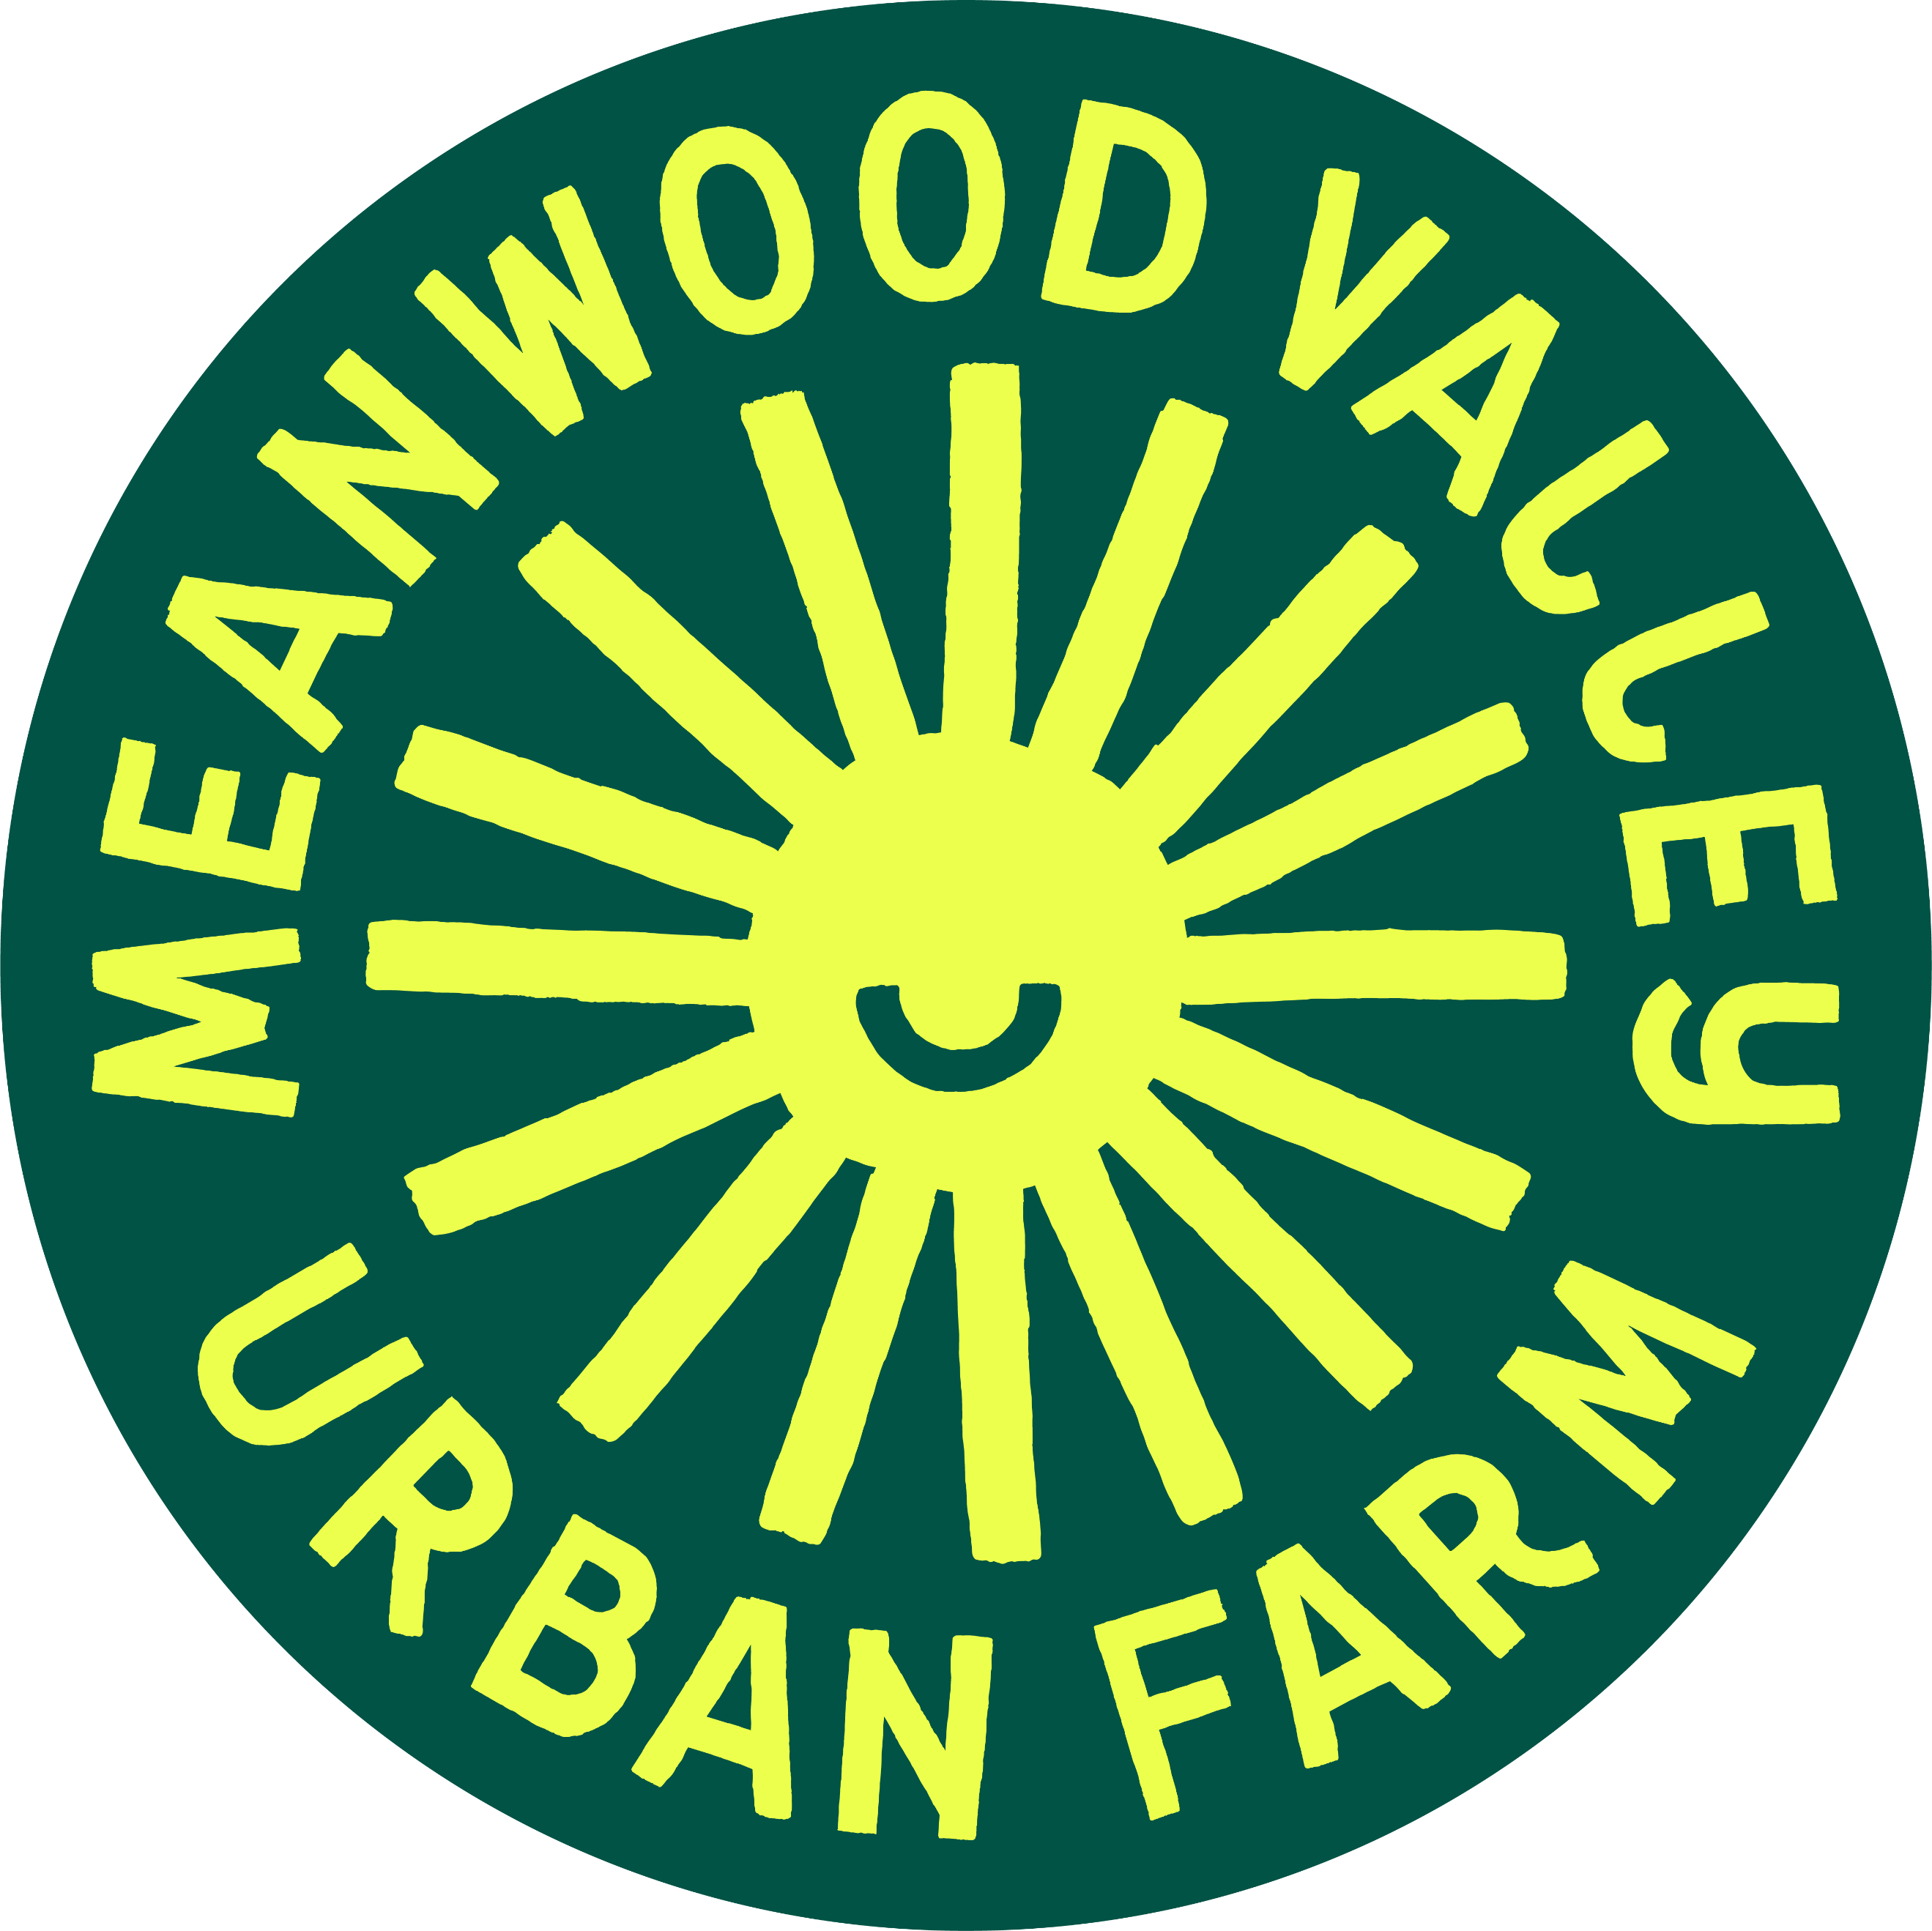

Communications and Engagement Officer

Job Purpose
We are looking for a motivated and dynamic person to provide communications and engagement support across the organisation. The main aspects of the role are marketing, social media, internal and external communications tasks, the arrangement & coordination of corporate volunteer days at the farm, devising new income generation ideas, helping organise seasonal events, trails and activities, and helping us to better engage with our existing users, with new individuals, and communities.

Conditions of Employment

Place of Work: Meanwood Valley Urban Farm

Pay: £13.14 per hour. Pension contribution

Hours of Work: 22.5 hours a week (Flexible as to which days and start and finish time)

Probationary Period: 5 months

Accountability: To the Chief Executive and Management Committee

Relationships: Directly responsible to Line Manager

Specific Responsibilities
- To carry out a range of administrative tasks relating to the arrangement and coordination of corporate volunteering days at the Farm
- To write, collate and create content for social media posts, to help coordinate our farm wide approach to social media and to respond to feedback/enquiries on our social media pages.
- To help devise and implement new income generation projects for the charity (e.g., events, fundraising, paid for experiences)
- To help organise seasonal events and activities including trails, pop up activities, summer, and Christmas fairs
- To undertake administration of our website and liaise with colleagues to create content for our website
- To help evaluate the organisations use of social media and marketing on an ongoing basis.
- To create content for newsletters, press releases and external marketing opportunities
- To help with the marketing of our projects and activities
- To help with community engagement activities including obtaining feedback from existing users of the farm and reaching individuals and communities who currently don’t know about our work.
- To lead on internal communications with staff, volunteers, trustees’, on site businesses, and partners
- Some design work on Canva, publisher and presentations may be required to support our external and internal communications

General Responsibilities
- To accurately complete all necessary documentation, records and reports as necessary and determined by MVUF’s procedures
- To interact with visitors to the Farm in a courteous, warm, and welcoming manner
- To promote wellbeing, safety and safeguard young people and adults with learning disabilities from abuse, recognising and responding to signs of abuse and neglect, ensuring that all safeguarding concerns are reported to the designated safeguarding person(s) and undertaking regular safeguarding training
- To treat people with respect and maintain dignity at all times
- To carry out other duties as required by the Line Manager
- To undertake training as part of a personal development programme
- To attend and participate in meetings, training and supervision sessions as required
- To comply with all MVUF policies and procedures including Health and Safety, and Equalities, Diversity and Inclusion
- To undertake a higher-level check with the Disclosure and Barring Service (DBS)

4. Personal Specification
Below are the types of skills, experience and knowledge required of applicants applying for the post. The ‘Essential Requirements’ indicate the minimum requirements and applicants lacking these attributes may not be considered for the post. The ‘Desirable Requirements’ are additional attributes to enable the applicant perform the position more effectively or with little or no training. They are not essential, but may be used to distinguish between acceptable candidates.
Skills | Essential | Desirable
Excellent IT skills (including Microsoft Office applications) | x
Good literacy and numeracy skills | x
Strong organisational & administrative skills with a problem-solving attitude | x
Ability to handle and process information from a variety of sources | x
Self-motivated, well organised and work proactively to take responsibility for own workload | x
Excellent verbal and written communication skills with the ability to communicate effectively over the phone, via email, face to face and online including responding to feedback and enquiries on our social media sites | x
Ability to proofread and edit documents and written communication | x
To write, collate and create content for social media posts | x
Ability to produce content for newsletters, press releases etc. | x
Video editing/making |  | x
Knowledge
Understanding of data protection and confidentiality | x
Knowledge of MVUF’s objectives | x
Understanding of community engagement techniques | x
Experience
Of working in a communications and engagement support role | x
Of using and developing administrative and database management systems | x
Of using social media tools within a business context | x
Of using WordPress or similar website content work | x
Of working with corporate groups or a willingness to learn | x
Of using Canva and or other design software/tools (or willingness and interest to learn) | x
Of devising activities that generate income for an organisation |  | x
Qualities and Behaviours
To be friendly, courteous, self-motivated, and welcoming | x
Flexible and adaptable | x
To understand and observe MVUF’s policies including Health and Safety and safeguarding policies | x
Positive attitude to inclusion, equal opportunity, and diversity | x

5. The following requirements are essential with this role
A satisfactory enhanced DBS Vetting

Confidentiality is a crucial aspect of this position. Details in respect of staff, management committee, students should not be released to anyone unless authorised by the Chief Executive or Management Committee.

6. How to apply for the job
A completed application form must be sent to admin@mvuf.org.uk. Alternatively, you may send or hand in person the application documents to:

Chief Executive, Meanwood Valley Urban Farm, Sugar Well Road, Leeds

LS7 2QG

The envelope must be clearly marked “Private & Confidential”.
Closing date: Completed applications must be received by 5pm on 6th November 2026
Shortlisted applicants will be required to attend an interview after which the successful candidate will be offered the position subject to the taking up of references.

