Risk Assessment Form 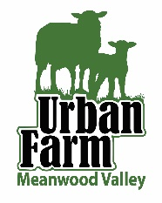

ACTIVITY: Spades and Forks

Responsible Manager |  |  |  |  |  | Signature |  |  | Issue no: 1 |  |  | Initial date:
Assessment by |  | Robert Paige |  |  | Signature |  |  |  | Date of this update | 8.7.22 |  | Review Date
What are the hazards? | Who might  be harmed and how |  |  | Evaluate the risks.  What are you already doing? |  |  |  | What further action is necessary? |  |  | Action  By  Whom? | Action By When? | Complete Y/N  (Date)
Children hit by spade because of incorrect handling  Severity - minor | Pupils / Learners |  |  | Children taught to carry spades/forks correctly |  |  |  | Monitor carrying of tools to and from site  Likelihood - low |  |  | Education Team | During task
Child injured by falling on Spade/Fork  Severity - minor | Pupils / Learners |  |  | Children taught how to dig carefully |  |  |  | Ensure site is appropriate for children to dig in, ie not too difficult.  Likelihood - low |  |  | Education Team | During task
Foot injured by jumping on spade/fork  Severity - | Pupils / Learners |  |  | Sturdy footwear worn  Use of hand and child size tools |  |  |  | Children supervised at all times |  |  | Education Team | During task

